ADHD Initial Screening Pack

If you are aged 18 or over and think you may have Attention Deficit Hyperactivity Disorder (ADHD) and want a referral for a diagnostic assessment for either, then please follow the below instructions with regards to an initial screening for this.

The below details are for adults aged 16 or over. If you are under 18 and are under a mental health team, such as CAMHS, then start by speaking with them about it, or book an appointment with your GP to discuss your symptoms. If you think your child may have ADHD, then you could also speak to your child’s SENCO lead in school, who could support and advise you on the appropriate referral route for your child.

Please be advised that for ADHD, your symptoms must have been present since childhood, and must affect your day to day functioning in some way. Please also be aware that both conditions can genetically run in families. If what you are experiencing can be explained by another mental health condition you will need to get in touch with your GP to see what else we can do to support you. In this case the referral will not be sent. If in doubt, please book in with our Mental Health Specialist Nurse, or a GP, to discuss this further.

INSTRUCTIONS
Please complete the “About You” section and the relevant questionnaire/s in this pack for ADHD.
If you have selected ADHD Primary Care Connect, please answer all the questions in the “About You” section. You do not need to complete the questionnaire on the last page.
If you have selected a different service to ADHD Primary Care Connect, please answer the initial “About You” questions and then complete the ADHD questionnaire on the last page.
Please then hand your form into reception or post them back to the surgery

REFERRAL OPTIONS
You have a choice of where you can be referred to, if your screening meets the criteria for referral on for diagnostic assessment.
There is currently at least a 7+ year wait to have a diagnostic assessment for ADHD with the local NHS Neurodevelopmental Service. Due to the demands on getting an assessment you can opt instead for a referral to ADHD Primary Care Connect under the NHS Patients Right to Choose, who can offer face to face and virtual assessments.
If you would like to be referred to ADHD Primary Care Connect, who have a significantly shorter waiting list, please inform the surgery by noting this in the “About You” section of this information pack.
Please also complete the ADHD Primary Care Connect Suitability Criteria Questionnaire, as we will need your answer to be able to refer you to this service.
You can opt for a different right to choose service, HOWEVER we can elect not to share care with other right to choose providers, given there is now a suitable local alternative which we expect to bring improvements in quality, safety and governance.

PLEASE NOTE :
IF YOU HAVE COMPLEX MENTAL HEALTH NEEDS, OR ARE CURRENTLY AT RISK, THEN WE CAN ONLY REFER YOU TO THE LOCAL SERVICE DUE TO SAFETY ISSUES WITH REFERRING TO OUT OF AREA SERVICES.
ADHD MEDICATION
If your assessment is for ADHD, and you are offered post assessment ADHD medication, then you will need to provide your personal measurements such as your height, weight, blood pressure, and pulse.
You can get your blood pressure and pulse readings by using our self-service machine in the ground floor reception waiting area of Park Crescent Health Centre.

Contact Details For Referral Services
If we have referred you to the local Neurodevelopmental Service for an assessment for ADHD/ASD their contact details are as follows:
Email: ESNDS@sussexpartnership.nhs.uk
Telephone: 0300 3040096

If you don’t meet the criteria to be referred, but would like to discuss your concerns with a GP, please inform the Reception Team who will be happy to book you in for an appointment. Please note there will be a few weeks wait until the next available appointment.

Useful Resources

https://adhdaware.org.uk/ (advertises local ADHD support group)

https://www.additudemag.com/ (has articles on emotional regulation and ADHD)

You may want to read the following information about ADHD from the Psychiatry-UK website:
https://psychiatry-uk.com/adhd/

See this ‘padlet’, an online resource which includes information for ADHD diagnoses such as local support, resources, participation opportunities and more.
https://padlet.com/ParticipationTeam/neurodevelopmental-participation-ifepyz61081lymhj

About You

Name……………………………………………………….

Date of birth………………………………………………..

Mobile number…………………………………………….

Email Address……………………………………………..

Please include an up-to-date BP reading:…………………………………

Service you consent to be referred to (please tick one only):

ADHD Primary Care Connect –

Local Neurodevelopmental Service -
Other Service - ………………………………………………………………………..

If you have selected ADHD Primary Care Connect, please complete the following questions. If you have selected a different service, please complete the ADHD Questionnaire on the last page.

What are your goals in exploring a diagnosis?

……………………………………………………………………………………………………………………………………………………………………………………………………

What symptoms did you experience as a child?

………………………………………………………………………………………………………………………………………………………………………………………………………………………………………………………………………………………………………

What current symptoms suggest a possible ADHD diagnosis?

…………………………………………………………………………………………………………………………………………………………………………………………………………………………………………………………………………………………………………………………………………………………………………………………………………

How does this impact your daily life?
…………………………………………………………………………………………………………………………………………………………………………………………………………………………………………………………………………………………………………………………………………………………………………………………………………
ADHD Primary Care Connect SUITABILITY CRITERIA:
You or your child are not suitable for an assessment with ADHD Primary Care Connect at this time if any of the following statements apply to you:
- Symptoms of severe mental illness (e.g. schizophrenia, bipolar disorder, personality disorder) causing significant risk or functional impairment
- Significant active substance misuse
- Significant current safeguarding concerns
- Active significant suicidal ideation
Do you declare that you have read the suitability criteria and that you are suitable for this service?
Yes No
If you answer yes to the following questions, please give details:
Do you have a family history of hypermobility?
……………………………………………………………………………………………………………………………………………………………………………………………………
Do you have a family history of Autism, ADHD or tics?
……………………………………………………………………………………………………………………………………………………………………………………………………

History of substance/alcohol misuse?
…………………………………………………………………………………………………………………………………………………………………………………………………………………………………………………………………………………………………………………………………………………………………………………………………………
Any current risks of harm to self or others?
…………………………………………………………………………………………………………………………………………………………………………………………………………………………………………………………………………………………………………………………………………………………………………………………………………

Supporting Accessibility Information

Do you require an interpreter?......................................................................................

If yes, what language?.......................................................................................

Do you have any accessibility requirements? (e.g cognitive, sensory, mobility)
………………………………………………………………………………………………………………………………………………………………………………………………………………………………………………………………………………………………………………………………………………………………………………………………………………………………………………………………………………………………………………………………………………………………………………………………………………

Will a third party/carer be present during your assessment?........................................

If yes, please provide their contact details Name:…………………………………………………………………………………Phone:…………………………………………………………………………………Consent given to discuss your referral if necessary? Yes No

Current Referrals

Are you on the waiting list for another provider?
If yes, please specify name of provider and date of referral:

Name:…………………………………………………………………………………………Date:……………………………………………………………………………………………

Are you currently pursuing an Autism assessment?
If yes, please specify name of provider and date of referral:
Name:…………………………………………………………………………………………Date:……………………………………………………………………………………………

Please only complete the following questionnaire if you have not selected to be referred to ADHD Primary Care Connect
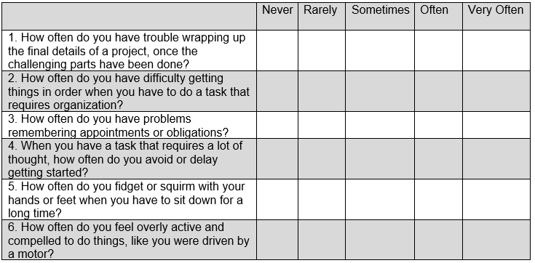
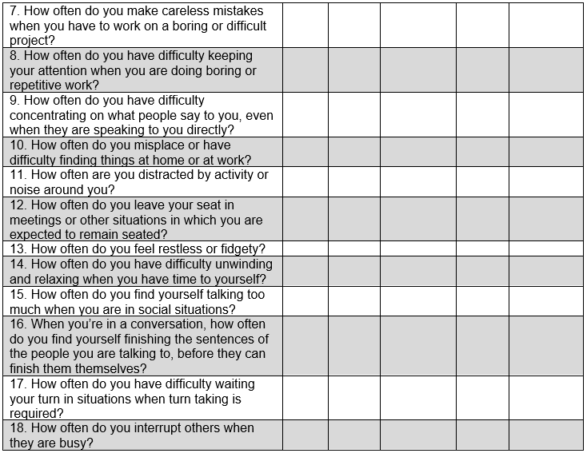
ONLY COMPLETE IF YOU HAVE CHOSEN NOT TO BE REFERRED TO ADHD PRIMARY CARE CONNECT
Please answer the questions below, rating yourself on each of the criteria shown using the scale on the right side of the page. As you answer each question, place an X in the box that best described how you have felt and conducted yourself over the past 6 months.

